 COSC 1320
Thanh Vo
B12
Name: _________________ Seat # ___

Estimated Hours 1
Actual Hours
1

TA (Textual Analysis) for UML USE CASE Diagram MODEL
Programming Assignment 3:
(15 points)
(Due date found in the COSC 1320 BB Calendar!)
You must use Microsoft WORD program. Insert the TEMPLATEs for Actors and Use Cases in this Requirements Document.

Please have Step 1, 2, 3, and 4 in this order.

PLEASE use the “TA for UML USE CASE Diagram MODEL Movie Company System.doc” AS TEMPLATE.
(Do not Show STEP 1,…; do not change Line Numbers; do not change Number of Pages)

Any DIAGRAM that is NOT the result of CUT and PASTE
WILL BE IGNORED. (YOU WILL GET ZERO POINTS)

Requirements Analysis: Construct the UML Use Case Diagram MODEL

Requirements Analysis: Construct the UML USE CASE Diagram MODEL

ProgrammingAssignment3 APPLICATION to automate adding, deleting, and displaying the list of employees in a hospital.
The set of Classes define these employees of a hospital: hospital employee, doctor, nurse, administrator, surgeon, receptionist, and janitor. MUST use inheritance in creating these Classes. You can use arrays to store objects of the same Class, you can assume MAX_SIZE = 5 or one array to store all objects of all the Classes, you can assume MAX_SIZE = 20.
(you are not to import STL Data Structures Classes - failure to conform will result in losing 20 points; you are not to use STL ArrayList or LinkedList or Vector Classes - failure to conform will result in losing 40 points; you are to use an C array - failure to conform will result in losing 30 points)

These employees are initially read and added from the “Programming Assignment 3 Data.txt” and are also saved in same file when your ProgrammingAssignment3 APPLICATION terminates.
UC5: UCSaveEmployee
A1: User
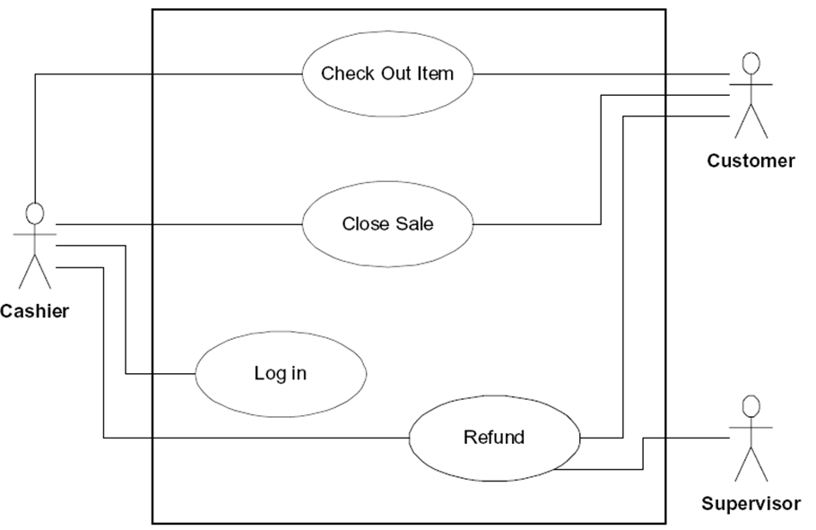
UC1: UCLoadEmployee
Your ProgrammingAssignment3 APPLICATION must read in the data file (FILE INPUT) into your ProgrammingAssignment3 APPLICATION memory (please DO NOT read from File and write to File skipping reading into the program memory).

Your ProgrammingAssignment3 APPLICATION must allow the user to delete a hospital employee, doctor, nurse, administrator, surgeon, receptionist, and janitor given the role and the name.
UC3: UCDeleteEmployee

Your ProgrammingAssignment3 APPLICATION must allow the user to add a hospital employee, doctor, nurse, administrator, surgeon, receptionist, and janitor.
UC2: UCAddEmployee

Your ProgrammingAssignment3 APPLICATION must allow the user to display the hospital employees in the format given below.
UC4: UCDisplayEmployee

Your ProgrammingAssignment3 APPLICATION must allow the user to save the hospital employees before it exits from the ProgrammingAssignment3 APPLICATION from the memory to the SAME data file (FILE OUTPUT) “Programming Assignment 3 Data.txt”.

Use Constructors to automatically initialize the instance variables that MUST be declared private - failure to make ALL member variables private will result in losing 20 points. Appropriate accessor and mutator methods for each private instance variable must be created.

Add (overwrite) the methods to display (must use toString method and super - failure to use toString will result in losing 10 points; - failure to use super will result in losing 10 points).

All Model Classes must have the equals and toString methods, please place them at the end of the Class.

MUST use inheritance in creating these Classes - failure to use inheritance will result in losing 20 points).
A sample input file “Programming Assignment 3 Data.txt” follows:

h Vito 123
d Michael 234 Heart
n Sonny 456 6
a Luca 567 Business
r Tom 678 Talking Y
j Anthony 789 Maintenance N
d Nicos 891 Bone

The h stands for hospital employee role, Vito for name (only one string), and 123 is its hospital employee number.

The d stands for doctor, Michael for name, 234 for number, and Heart for specialty.

The s stands for surgeon, Vincent for name, 345 for number, Brain for specialty, and Y for operating.

The n stands for nurse, Sonny for name, 456 for number, and 6 for numpatients.

The a stands for administrator, Luca for name, 567 for number, and Business for department.

The r stands for receptionist, Tom for name, 678 for number, Talking for department, and Y for answering.

The j stands for janitor, Anthony for name, 789 for number, Maintenance for department, and Y for sweeping.

Format to display the Hospital Employees use the following format (must use the toString() method):

The Hospital has the following employees:

Hospital Employees: 1
Name: Vito Employee Number: 123

Doctors: 2
Name: Michael Employee Number: 234 Specialty: Heart
Name: Nicos Employee Number: 891 Specialty: Bone

Surgeons: 0

Nurses: 1
Name: Sonny Employee Number: 456 Number of Patients: 6

Administrators: 1
Name: Luca Employee Number: 567 Department: Business

Receptionists: 1
Name: Tom Employee Number: 678 Department: Talking Answering: Y

Janitors: 1
Name: Anthony Employee Number: 789 Department: Maintenance Sweeping: N

Total number of Employees: 7

Create a ProgrammingAssignment3. cpp that contains the main method.

A1: User
Controller
UCLoadEmployee
UC 1

UC2

UC3

UC4

UC5

UCAddEmployee
UCDeleteEmployee
UCDisplayEmployee
UCSaveEmployee

UC1 UCLoadEmployee Description
Name: | UC1: UCLoadEmployee
Actor: | none
Description: | This use case interprets a process which program opens a text file then streams in the information sets of all employees
Successful Completion: | User starts the program. The program finds the directory path to the text file and opens it. All information required for the program in the text file is streamed in and assigned to appropriate variables. After finished, the program closes the text file
Alternative | If there is no text file in the same directory as the program, the program will give notification for no text file found. The program still can add and delete information set(s) of employee then save to text file
Pre-condition: | The instance variables for each class and for the counters is empty
Post-condition: | The instance variables for each class are filled with the information streamed in from text file successfully or unsuccessfully. The instance variable for counters is filled with number of sets of information appeared in each class and all classes.
Assumptions: | None

UC2 UCAddEmployee Description
Name: | UC2: UCAddEmployee
Actor: | User
Description: | This use case interprets a process which program adds another set(s) of information of employee(s)
Successful Completion: | User requests Add employee(s)  - The program asks User input for the initial letter of role following by instruction  - The program matches the role with each case of hospital employee. (Employee, Doctor, Surgeon, etc)  - Depending on type of hospital employee, the program requests User to input next appropriate information to fill the entire set of information  - This set of information is stored in instance variable for correspondent class of hospital employee; also, the counters for correspondent class and for all employees increase by 1  - The program repeats this procedure until User presses ‘E’ or ‘e’ for exit Add option
Alternative | None
Pre-condition: | Current instance variables for each class with current sets of information of hospital employees, and current counter for all employees and correspondent class
Post-condition: | Instance variables for each class with current sets plus one or more added sets (by User) of information of hospital employees, and counter for all employees and correspondent class increased by 1
Assumptions: | None

UC3 UCDeleteEmployee Description
Name: | UC3: UCDeleteEmployee
Actor: | User
Description: | This use case interprets a process which program deletes set(s) of information of employee(s)
Successful Completion: | User requests Delete employee(s)  - The program asks User input for the initial letter of role following by instruction displayed  - The program matches the role with each case of hospital employee. (Employee, Doctor, Surgeon, etc)  - Depending on type of hospital employee, the program requests User to input name of employee in order to search for appropriate set of information  - This set of information is then deleted by shift the rest of list of sets of information up then set the final set of information to null; also, the counters for correspondent class of hospital employee and for all employees decrease by 1  - The program repeats this procedure until User presses ‘E’ or ‘e’ for exit Delete option
Alternative | None
Pre-condition: | Current instance variables for each class with current sets of information of hospital employees, and current counter for all employees and correspondent class
Post-condition: | Instance variables for each class with current sets minus one or more deleted sets (by User) of information of hospital employees, and counter for all employees and correspondent class decreased by 1
Assumptions: | None

UC4 UCDisplayEmployee Description
Name: | UC4: UCDisplayEmployee
Actor: | User
Description: | This use case interprets a process which program display all sets of information of employees, and the counters for all employees and employees in each type
Successful Completion: | User requests Display the list of employee(s)  - The program displays the counter and the set(s) of information for correspondent class of hospital employee  - The program display the counter for total number of employees in the hospital
Alternative | None
Pre-condition: | Current instance variables for each class with current sets of information of hospital employees and current counters
Post-condition: | Output to the screen current sets of information of hospital employees stored in the instance variables for each class and counters
Assumptions: | None

UC5 UCSaveEmployee Description
Name: | UC5: UCSaveEmployee
Actor: | None
Description: | This use case interprets a process which program opens a text file then streams out the information sets of all employees
Successful Completion: | User chooses to exit the program. The program finds the directory path to the text file and opens it. All information sets of hospital employees are streamed out to the text file. After finished, the program closes the text file
Alternative | If there is no text file in the same directory as the program, the program will give notification for no text file found and exit the program immediately
Pre-condition: | Current instance variables for each class with current sets of information of hospital employees
Post-condition: | Current instance variables for each class with current sets of information of hospital employees are listed in the text file following the order of type of employee successfully or unsuccessfully
Assumptions: | None

